Postal Life Insurance

Department of Post

Software Requirements Specification (SRS)
  - Web Portal for Employer

INTERNAL APPROVAL FORM

Project Name: Web Portal for Employer
Version: 1.0
Submitted on:
 | Name | Date
Approved By:
Reviewed By:
Prepared By:

VERSION CONTROL LOG
Version | Date | Prepared By | Remarks
1

Table of Contents

1. Executive Summary 4
2. Scope 4
3. Business Requirements 4
4. Functional Requirements Specification 6
4.1 Login Page 6
4.2 Employer Registration Page 6
4.3 Dashboard Page 8
4.4 Policy List Page 9
4.5 Add Policy Page 9
4.6 Bulk Upload Page 10
4.7 Payment Processing Page 12
4.8 Receipt Generation Page 14
4.9 Reports Page 15
4.10 Profile Management Page 15
7. Appendices 15

1. Executive Summary
The Purpose of this document is to define the requirements for a web-based portal that enables employers (non-postal Drawing and Disbursing Officers – DDOs) to manage Postal Life Insurance (PLI) policies for their employees. The portal will facilitate premium collection through salary recovery, bulk policy management, payment processing, and reporting.

2. Scope
This Portal will allow employers to:
- Register and authenticate securely.
- Upload and manage employee PLI policies (individually or in bulk).
- Upload Premium Payment Information
- Generate receipts and reports.
- Access dashboards for monitoring policy and payment status.

3. Business Requirements
Requirement ID | Feature | Requirement
FS_CP_001 | Employer Registration & Access | Employers (non-postal DDOs) must be able to register and obtain secure access credentials.
FS_CP_002 | Employer Registration & Access | Registration should capture organization details, authorized personnel information, and contact details.
FS_CP_003 | Secure Authentication | Non-Postal DDO user should be able to Login using a unique Group Code and password. Password management features (reset, lockout after invalid attempts, history prevention) should be present.
FS_CP_004 | Policy Management | Employers must be able to add employee policies individually or through bulk upload.
FS_CP_005 | Policy Management | Validate policies against PLI database and enforce rules (e.g., policy mode = “Pay”, no maturity within 30 days). Display policy details in a standardized format.
FS_CP_006 | Premium Collection via Salary Recovery | Enable employers to process premium payments deducted from employee salaries.
FS_CP_007 | Premium Collection via Salary Recovery | Ensure salary recovery month matches premium month.
FS_CP_008 | Payment Processing | Provide multiple payment options: Internet Banking, NEFT, RTGS.
FS_CP_009 | Payment Processing | Real-time payment confirmation.
FS_CP_010 | Payment Processing | Validate payment rules (active policy, no outstanding loans, not surrendered/ lapsed).
FS_CP_011 | Receipt Generation | Generate receipts with unique transaction ID, organization details, policy list, amount breakdown, and payment timestamp.
FS_CP_012 | Receipt Generation | Allow PDF download and deletion of wrongly generated receipts.
FS_CP_013 | Dashboard & Reporting | Dashboard showing total policies, premium due, recent payments, pending requests, and notifications.
FS_CP_014 | Dashboard & Reporting | Export policy list and payment history to Excel.

Flow Diagram for the Employer Portal: 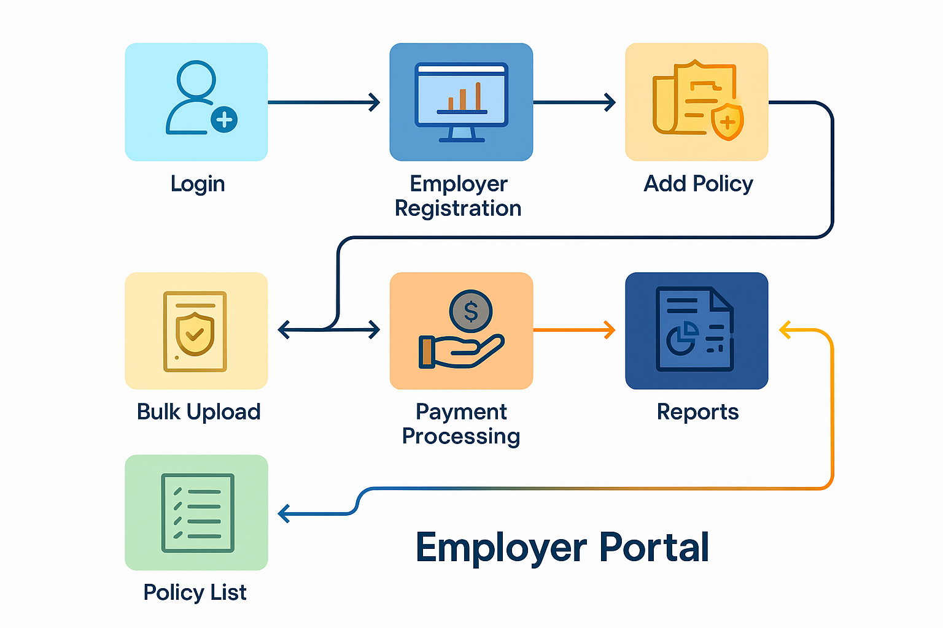

4. Functional Requirements Specification
If a non- postal employee chooses the Pay Recovery method for payment of PLI renewal premiums, the employee must submit the necessary details to their Drawing and Disbursing Officer (DDO) for premium deduction from their salary. The DDO will then transfer the deducted amount and update the policy records.

4.1 Login Page
- Purpose: Authenticate employer users securely.
- Fields:
  - Username: Text: Special Group Code is User Name.
  - Password: Text
  - Login: Button: To Login to Dashboard after Two-Factor Authentication Code (OTP via mobile/email).
  - Reset/Forget Password: Link: Option to Reset Password after Two-Factor Authentication Code (OTP via mobile/email) should be given.
- Details:
  - Password reset via registered mobile/email.
  - Maximum 5 invalid attempts before temporary lockout.
  - Password history prevention (last 5 passwords).

4.2 Employer Registration Page
- Purpose: Allow new employers (non-postal DDOs) to register for portal access.
- Fields:
  - Organization Name: Full legal name of employer.
  - Group Code: Unique code assigned by India Post.
  - Authorized Person Name: Name of the person managing the portal.
  - Designation: Role of the authorized person.
  - Contact Number: Mobile number for OTP and communication.
  - Email ID: For notifications and password reset.
  - Office Address: Complete postal address.
  - Upload Authorization Letter: PDF or image file validating authority.

- Details:
  - Special Group Code should be assigned as username.
  - Password minimum 8 characters with complexity.
  - Mandatory two-factor authentication.
Flow Chart for Employer Registration:
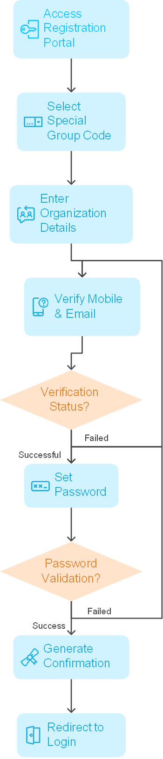

4.3 Dashboard Page
- Purpose: Provide a summary view of policies and payments.
- Components (Display Only):
  - Total Policies: Count of active policies.
  - Premium Due: Amount due for current month.
  - Recent Payments: Last 5 transactions.
  - Pending Requests: Service requests awaiting action.
  - Notifications: System alerts and updates.
  - Provide Navigation tabs for moving to following pages:
    - Policy List Page
    - Add Policy Page
    - Bulk Upload Page
    - Payment Processing Page
    - Receipt Page
    - Reports Page
    - Profile Management Page
- Details:
  - Interactive charts for premium trends.
  - Quick links to policy list and payment module.
Wireframe for the Dashboard Page:
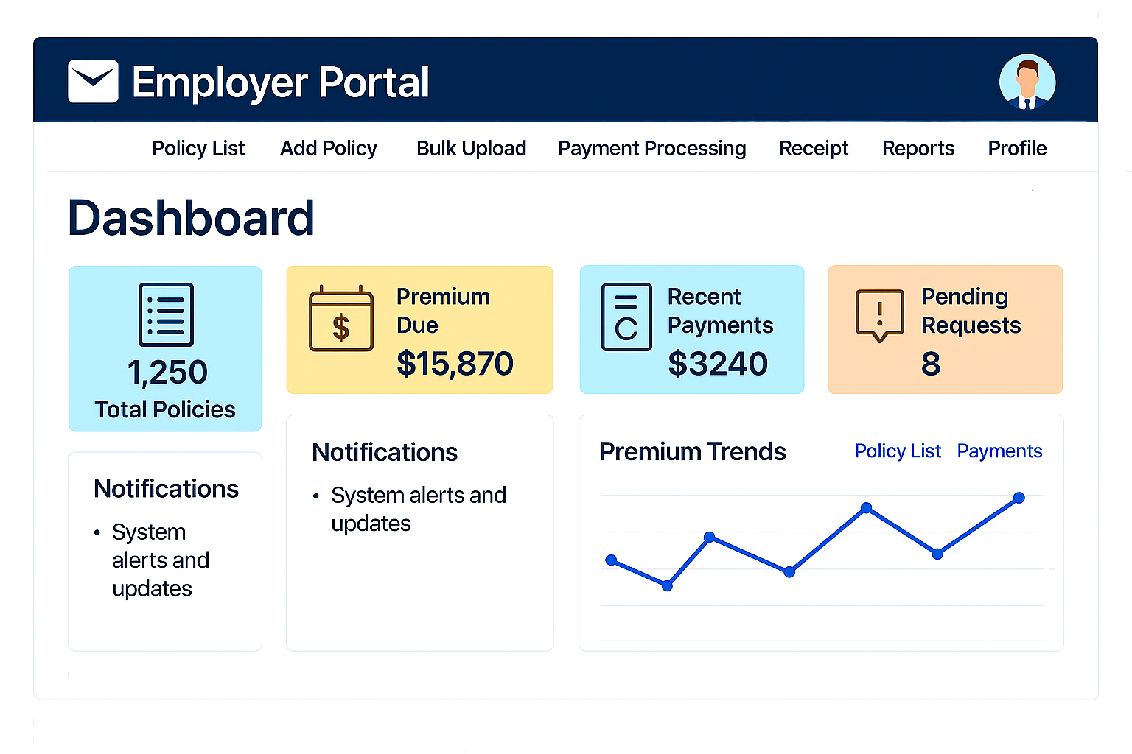

4.4 Policy List Page
- Purpose: Display all managed policies with search and filter options.
- Fields (Display Only Table):
  - Policy Number
  - Insurant Name
  - Maturity Date
  - Last Premium Date
  - Premium Paid To Date
  - Premium Amount
  - Policy Mode (Pay/Cash)
- Details:
  - Filters: Active/Inactive, Premium Due, Policy Mode.
  - Export to Excel option.
  - Option to Add new policies individually or in bulk
  - Option to Remove policies from active list
  - Option to Modify policy details
  - Option to Export policy list to Excel
- Policy Display Format
The system shall display policy details in the following format:
Policy Number | Insurant Name | Maturity Date | Last Premium Date | Premium Paid To Date | Premium | Policy Mode
PLI123456789 | Employee Name | DD-MM-YYYY | DD-MM-YYYY | DD-MM-YYYY | Amount | Pay/Cash

4.5 Add Policy Page
- Purpose: Add a new policy manually.
- Fields:
  - Policy Number: Must match PLI database.
  - Insurant Name: Employee name.
  - Date of Birth: For validation.
  - Policy Start Date: Original start date.
  - Premium Amount: Monthly premium.
  - Policy Mode: Must be “Pay”.
- Details:
  - Validate policy against PLI database.
  - Check rules like no maturity within 30 days, no duplicates.

4.6 Bulk Upload Page
- Purpose: Upload multiple policies via Excel/CSV.
- Fields:
  - Upload File: CSV/Excel containing policy details.
  - Template Download: Link to correct format.
- Details:
  - Validate file format and data integrity.
  - Show error report for invalid entries.
- Policy Validation Rules:
  - Policy must exist in PLI database.
  - Policy mode must be "Pay" (not "Cash").
  - Premium payment not allowed if maturity within 30 days.
  - Salary recovery month must match premium month.
  - No duplicate policy entries.

Flow Chart for Bulk Upload of Policies by Employer: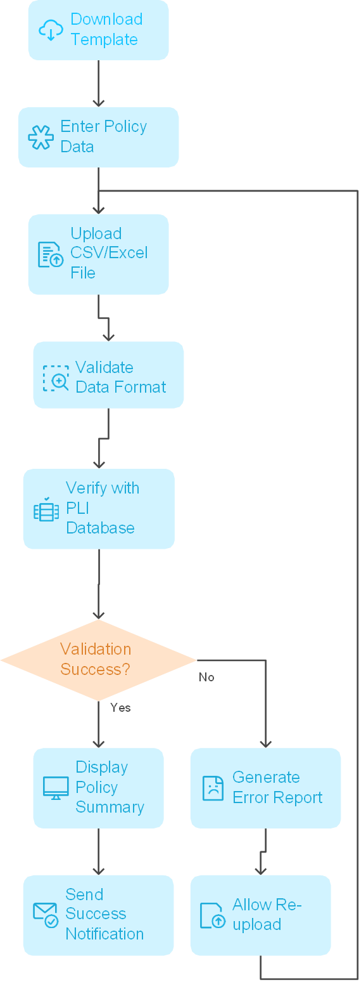

4.7 Payment Processing Page
- Purpose: Process premium payment for selected policies.
- Fields:
  - Select Policies: Checkbox list of policies due.
  - Total Premium Amount: Auto-calculated.
  - Payment Method: Internet Banking / NEFT / RTGS.
  - Transaction Reference: Auto-generated after payment.
- Details:
  - Real-time payment confirmation.
  - Validate payment rules: active policy, no outstanding loans, not surrendered/lapsed.
- Payment Validation Rules:
  - Premium must be paid up to current month
  - Policy must be in active status
  - No maturity within 30 days
  - No outstanding loans affecting premium
  - Policy not surrendered or lapsed
- Payment Gateway Options:
  - Internet Banking (All public and private sector banks)
  - NEFT Transfer
  - RTGS Transfer
  - Real time Payment confirmation.
- Receipt Format:
  - Transaction Type: ‘Premium Payment’
  - Unique 16-digit transaction ID
  - Organization details
  - List of all policies paid
  - Amount breakdown
  - Payment date and time
  - Downloadable PDF format
  - Option to delete the wrongly generated receipt

Flow Chart for Payment Processing by Employer: 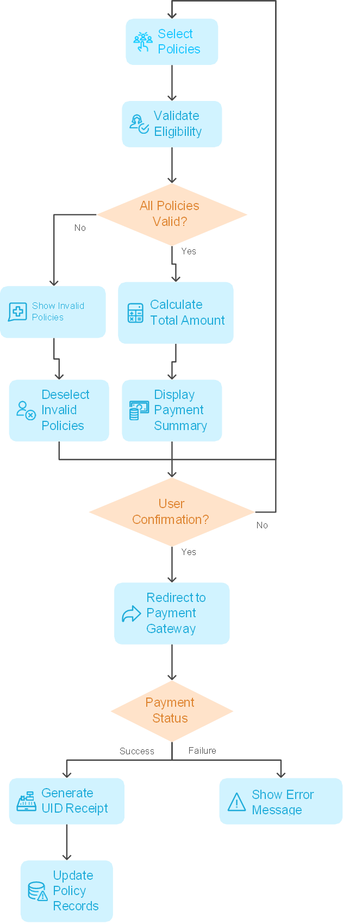

4.8 Receipt Generation Page
- Purpose: Generate and download payment receipts.
- Fields:
  - Transaction ID: Unique 16-digit number.
  - Organization Details: Employer name and Group Code.
  - Policy List: Policies included in payment.
  - Amount Breakdown: Premium per policy.
  - Payment Date & Time: Timestamp.
  - Download PDF: Button.
  - Delete Receipt: Option for correction.
- Details:
  - PDF Download Options.

Sample Receipt:
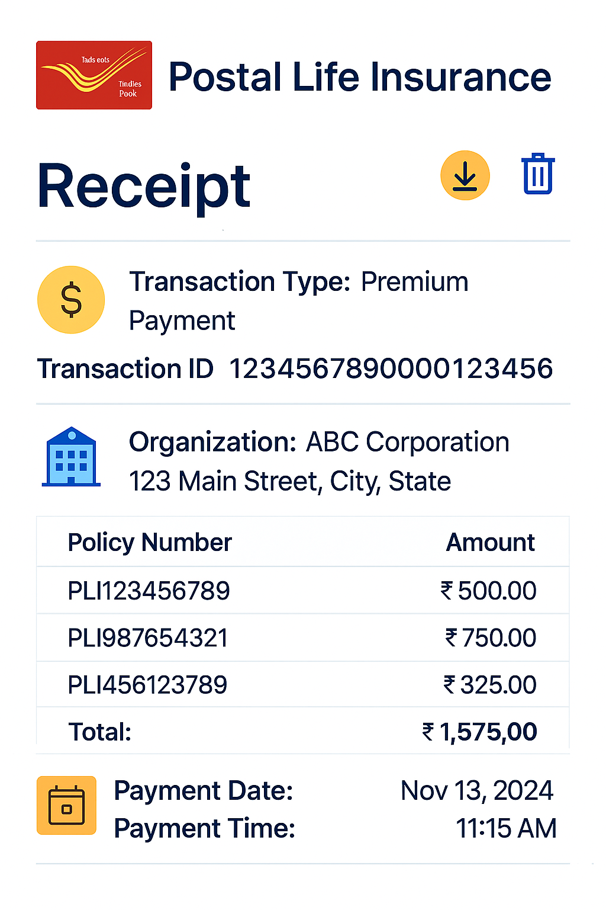

4.9 Reports Page
- Purpose: Generate and export reports.
- Fields:
  - Report Type: Policy List / Payment History.
  - Date Range: Start and end date.
  - Export Format: Excel / PDF.
- Details:
  - Include filters for policy status and payment status.

4.10 Profile Management Page
- Purpose: Allow new employers (non-postal DDOs) to register for portal access.
- Fields:
  - Organization Details: Editable fields.
  - Contact Information: Mobile and email.
  - Change Password: Old password, new password, confirm password.
  - Two-Factor Settings: Enable/disable OTP.

7. Appendices
The Following Documents attached below can be used.

